Tennessee Tourism 2022 Media Kit
What’s New (Annual and Quarterly)
Discover new attractions, exhibits, venues, restaurants, breweries, distilleries, state-of-the-art expansions, milestone anniversaries and events across the state in our annual and seasonal What’s New.

Tennessee Music Pathways
Walk in the footsteps of legends, musical pioneers and watch songwriters perform live on stage along the Tennessee Music Pathways. The statewide driving tour connects visitors to the people, places and genres that make Tennessee the Soundtrack of America. From cities to small towns, the initiative identifies and preserves music history through markers at birthplaces, resting places, hometowns, high schools, churches and locations of first-known recordings of musicians who’ve shaped the seven genres of music home to Tennessee.
History Reimagined
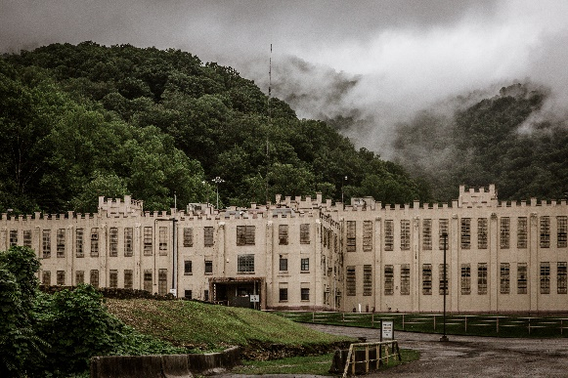
What’s old is new and history is reimagined at hidden gems across the state. Former prison guards give tours at Historic Brushy Mountain Penitentiary, in Petros. Enjoy lunch at the Warden’s Table and taste moonshine distilled on site. Named after Thomas Hughes’ alma mater in England, Rugby was conceived of as a utopia and is now offers visitors a museum, historic building tours, lodging, shopping and a restaurant. Adventure into a cave turned into a music venue and home of The Bluegrass Underground at The Caverns in Pelham. . Other spots include Marathon Village and Marathon Music Works in Nashville, Granville’s Sutton Old Time Music Hour at T.B. Sutton General Store and Central Station Hotel in Memphis. Unplug from what is and relive what was with these incredible stories of Tennessee.
14 Tennessee Stops on the U.S. Civil Rights Trail
Learn the stories of brave men and women who brought words to action through peaceful protests and legal actions to secure their civil rights. Follow their footsteps through the National Civil Rights Museum in Memphis, the Civil Rights Room and Witness Walls in Nashville to stories of 12 students who changed history at Green McAdoo Cultural Center in Clinton in East Tennessee. In February 2022, two new stops were added in Tennessee along the U.S. Civil Rights Trail, including Stax Museum of American Soul Music in Memphis and the National Museum of African American Music in Nashville. Travelers can also document their visits and redeem their “stamped” passports for prizes, all from their mobile device, using Bandwango. Passports are available online.
Colorblind Viewfinders
Tennessee has beauty for all to see. Visitors with red-green color blindless are now able to enjoy fall leaves bursting with color and spring’s beautiful flowers with special viewfinders at 13 scenic locations across the state, including Ober Gatlinburg in the Smoky Mountains, the Cherohala Skyway Lake View Overlook and Meeman-Shelby Forest State Park near Memphis. The viewfinders, which have innovative EnChroma lenses, let travelers see the bold colors of the changing seasons.
The Ultimate Road Trip - Discover Tennessee Trails & Byways
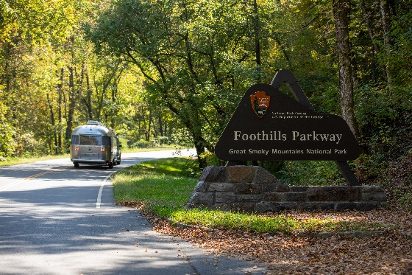
Stumble upon hidden gems while you take the scenic route. These 16 self-guided driving routes connect Tennessee’s 95 counties so you can discover places you never knew you’ve always wanted to visit. Trails feature attractions, restaurants and unexpected stops as you walk in the footsteps of legends and discover Tennessee.

Outdoor Adventures
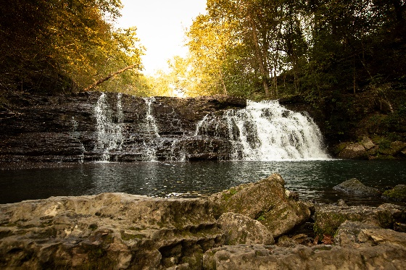
The Great Outdoors, the kind that look like a postcard and feel like a playground. Tennessee is home to Great Smoky Mountains National Park, the most visited national park in America and treasure trove for hiking, fishing and outdoor scenic beauty. Escape into the outdoors at 56 state parks, which all offer free admission for hiking, kayaking, rafting, paddleboarding, boating and other outdoor adventures. Cool off at nearly 10,000 caves, including Ruby Falls in Chattanooga, the Lost Sea in Sweetwater and Tuckaleechee Caverns in the Great Smoky Mountains. Find solitude in the natural beauty of cascading waterfalls, including Twin Falls at Rock Island State Park.
Family-Fun & Kid Reviewed
Explore scientifically proven family fun at nearly 30 attractions across the state. Tennessee Tourism’s award-winning Kid Reviewed campaign featured kids wearing laugh trackers to monitor laughter, heart rates and levels of excitement. The data is paired with candid reviews and surveys from kids.
A Taste of Tennessee
Savor Southern comfort food like barbecue, biscuits and hot chicken that feeds your soul or fresh new farm-to-table eateries, mom-and-pop diners, hidden gem cafes and award-winning restaurants across the state. Explore and sip along a wine trail, the Tennessee Whiskey Trail, take a brewery tour and bring your favorites home. Come hungry. Leave satisfied.

Tennessee Whiskey Trail
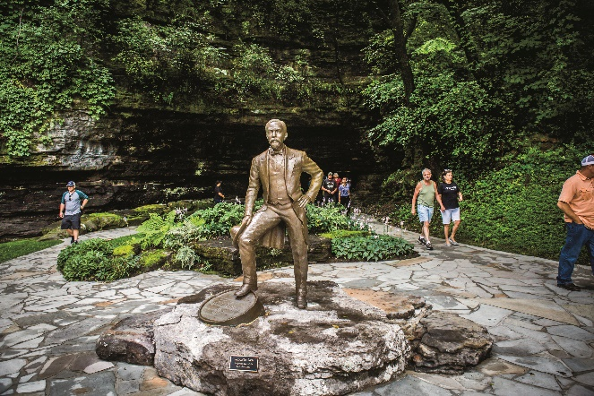
Adventures run on Tennessee Whiskey. Listen to stories of the rich history of the craft at 28 registered distilleries along the Tennessee Whiskey Trail. Before you leave Jack Daniel Distillery in Lynchburg, visit downtown shops, and make a reservation for a homecooked meal at Miss Mary Bobo’s. Explore the rolling hills to discover great stories at Tennessee Legend Distillery in Sevierville, Old Dominick in Memphis, Cascade Hollow Distilling in Tullahoma, Uncle Nearest Distillery in Shelbyville; where Victoria Eady Butler, a descendant of Nathan “Nearest” Green, is the first African American woman master blender. Make sure to pick up a copy of the printed Tennessee Whiskey Passport at any of the participating distilleries. Or, download the official TN Whiskey Trail app for your iOS or Android device to access a digital passport.
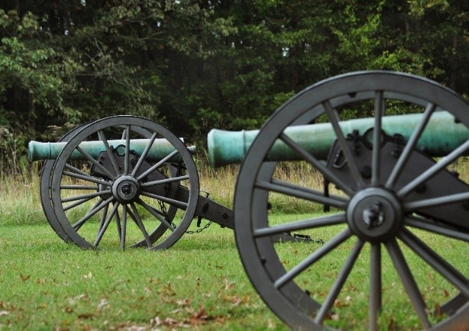
Civil War Trails
Visitors can follow in the footsteps of generals, soldiers, citizens and the enslaved. Preserved battlefields and homes tell the stories of the war that tore the country apart when the sounds of cannons shook the ground and family homes turned into hospitals. Hear the stories of soldiers and civilians through letters they wrote on a lantern tour at Stones River National Battlefield in Murfreesboro. Overlooking the Battle of Franklin sits Carnton, a private-home turned field hospital and provided land for the Confederate cemetery. Step in the shadow of one of the Civil War’s most definitive battles at Shiloh National Military Park.
Find additional travel inspiration and images at press.tnvacation.com
Contact Information:
Jill Kilgore
PR Media Manager, Jill.Kilgore@tn.gov , 615-927-1320
Amanda Murphy
Director of Communications, Amanda.Murphy@tn.gov, 615-927-6081
Mary Katelyn Price
Communications Specialist, MaryKatelyn.Price@tn.gov, 615-351-2334

